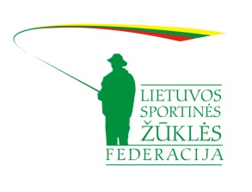

3nd TROUT AREA WORLD CHAMPIONSHIP
Vasaknos, Zarasai, Lithuania
4th & 5th November 2023

Registration form for participants

Country: _____________________________

Federation: _____________________________

Name | Surname | Competitor
 |  | Competitor
 |  | Competitor
 |  | Competitor
 |  | Competitor
 |  | Competitor
 |  | Captain 1
 |  | Captain 2
 |  | Delegate

Registration forms shall be sent by e-mail: tomasbudas@inbox.lt until 5th of October 2023

